**Chapter 3&4 Task**

**Instructions:**

**-Study well and please attach Screen shots from the executable code in addition to sample of queries' results in your Answers.**

**- If you want to know any column name in a specific table you have to apply describe command: desc table_name.**

**-HR schema:**

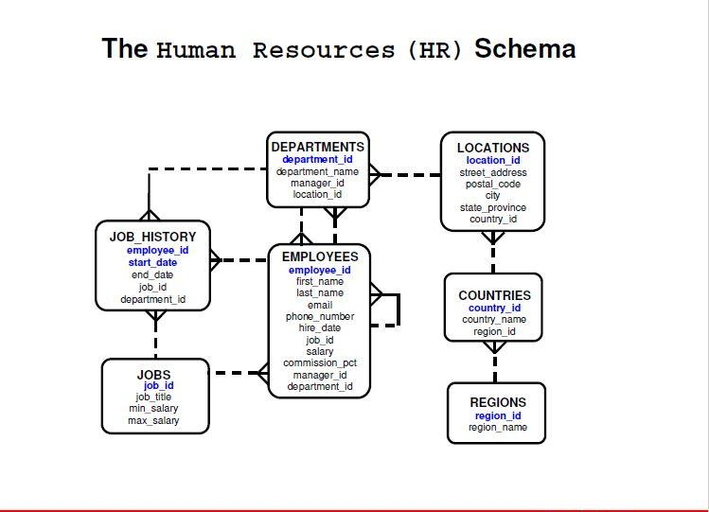

**1- Display the  
 employees' names concatenated  
 and commissions for all Employees,  
 if no commission, displays (no commission),  
 you can display the first four rows.**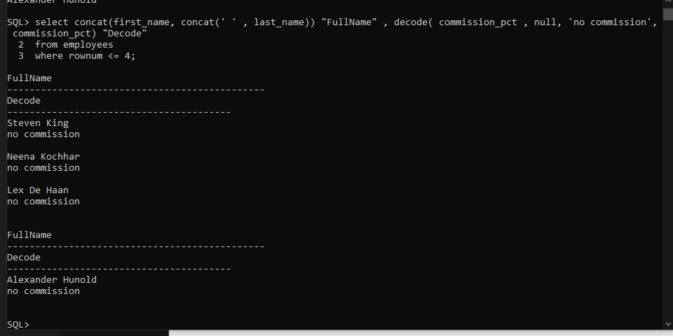

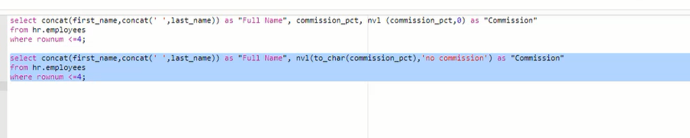

**2- Display the employees' names and commissions for all employees, if no commission, displays (0) hint (you can display the first four rows).**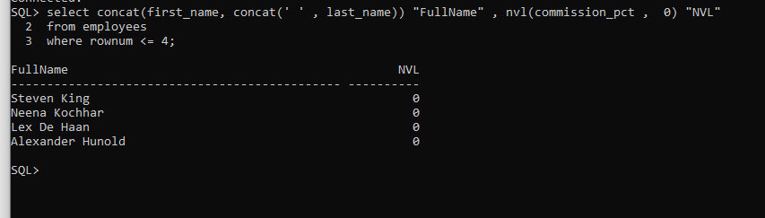

**3- Write a query using   
Decode & case as single row functions  
 that displays the grade of all employees   
based on the value of the column Job_id  
, as per the table shown below:**

|  |  |
| --- | --- |
| **JOB** | **GRADE** |
| **AC_ACCOUNT** | **A** |
| **AC_MGR** | **B** |
| **AD_ASST** | **C** |
| **AD_VP** | **D** |
| **IT_PROG** | **E** |
| **None of above** | **O** |

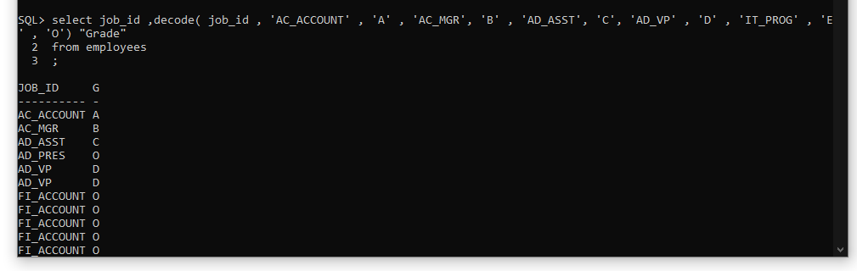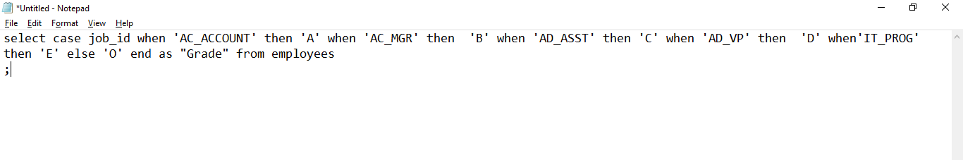

**4- Display the   
employees' first and last names   
and compare between their first and last name number of characters [Length] as Result**

**Hint (you can print the first four rows).**

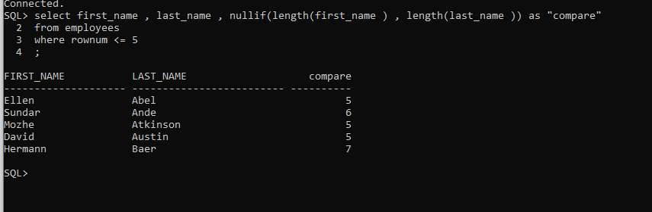

**5-   
Accept an employee number as a user input with sql*plus substitution variable,**

**if employee salary is less than 1000  
 set the commission amount of employee to 10%,**

**if employee salary is between 1000 and 2000  
 set the commission amount of employee to 15%,**

**if employee salary is greater than 2000  
 set the commission amount of employee to 20%.**

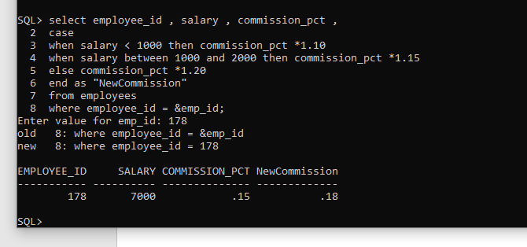

**6-Display the date of the following:   
Today,  
 Next (Friday) from '1-Jan-2019',  
 last day of February 2020,   
the no.of months between 1-Jan-2019 and 20-Aug-2019.**



